October 12, 2019 | 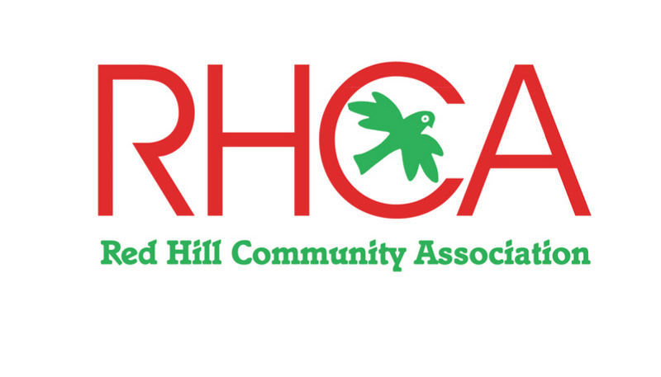
CHAIRMAN’S REPORT – 2019

RHCA has continued to play an important role in representing its members and the community in a range of issues and has been involved with key groups, the Red Hill Ward Mayor Cr David Gill and the Residents Associations Meetings (RAM), Mornington Peninsula Shire (MPS) officers, and local Landcare groups. Key issues for 2018/19 have included:

Community BBQ
With the financial support of the Shire, RHCA organised and conducted the “community building” bbq on 27 January, 2019 in our community park. More than 200 adults and children enjoyed the feast and special thanks to the 1st Red Hill Scouts for their chef-work, music by Keith White and storytelling by Wendy Orr and Hugh Dolan. Face-painting was popular for the children and the parkland and playspace provided exactly what it was intended for. This year a real feature was a walk and talk with local Aboriginal guide, Lionel Lauch through the adjacent bushland reserve followed by a didgeridoo meditation session. Special thanks to Kerry Watson for obtaining the funding which will be repeated for the next year.

Red Hill Station Reserve Master Plan
Again we sought funding for the continuation of this project aimed at the station platform area near the bike skills park. The platform shelter is a main element of the area.
The Shire’s 2019/20 budget provided for the project ($104,000) and it should be completed by June 30, 2020.

War Memorial
The services for Remembrance Day and ANZAC Day were well attended. These services are important not only for the remembrance and acknowledgement of the service men and women of Red Hill and Main Ridge but also for all the men and women of Australia that served and the families.
As an addition in the memorial space we now have a plaque which acknowledges the contributors and donors to the project.
Many thanks to our local musician Keith White, the Red Hill Scouts and bugler Lewis Coard for their contribution to the service.

Traffic Management
The traffic study was completed by OneMileGrid and RHCA contributed extensively to the consultant. The consultation with this firm was lacking and we have yet to see any implementation.
RHCA, locals and parents that drop off and pick up students have great concerns about the situation with traffic in the area around Red Hill Consolidated School.
Increased numbers of visitors attracted to our area has heightened the need for better traffic control and safer roads throughout Red Hill.
The Red Hill Lions Club are very experienced in traffic management through the Red Hill market and are continuing discussions with the school council and Shire officers.

RAM
Mayor David Gill has continued the quarterly RAM (Residents Association Meeting) which enabled each of the Red Hill Ward associations to present any issues and for them to gain information from Shire officers and for the selected managers to get feedback from the attendees.

Green Wedge Management Plan
RHCA combined with other community associations and Landcare groups made submissions for the draft GWMP 2019. This important review will set the basis for protecting the Green Wedge Zone of the Peninsula and recognition by the State government.

Biodiversity Conservation Management Plan
RHCA and community members added to the submission by Landcare groups toward development of the draft BCMP due for approval by Council in 2019.

Westernport Coastal Villages Study
On the Westernport side of the peninsula, Balnarring, Baxter and Somerville were identified as key parts of this study due and “Township Structure Plans” are being developed.
Red Hill and other villages in the Red Hill Ward had the opportunity to make submissions concerning their individual neighbourhood character. These plans are due for development by Ethos Urban in 2019.

NBN
No indication of when the “fixed wireless” plans for our area will be initiated.

Exposure
RHCA’s website at www.redhillcommunityassociation.com has been kept up-to-date by Kerry Watson and it enables our members and the public know about our purpose, committee, our activities and issues and displayed our current and past Newsletters. Newsletters were done on an as need basis for the website. Articles were submitted to the Lions publication “Hill n Ridge”. We have now developed a Facebook page and a new Notice board is near the shops beside the school.

Bunnings Barbecue
A key fund raiser for the group is now a Bunnings barbecue at Rosebud and which we will continue annually. A lot of organisation is involved and many thanks to John Eldridge for his part.

Membership
With excellent work by RHCA over the past year and local communication, we have maintained our membership to 65 individuals and families. A good sign that RHCA is supported and making a valuable contribution to the community.

Looking Forward
RHCA looks forward to working closely with the Shire and Councillors on many matters of interest to our community and Red Hill Ward.

Committee members dedicate a lot of time to support the interests of the members and the community with their attendances at meetings, communications with MPs, Councillors and Shire officers as well as communicating with our members and contacts.

We now hold our monthly meetings at the “Epicurean” each third Thursday of the month and anyone is welcome to attend. The venue enables us to spend a bit of social time together.

The committee of Kerry Watson, Libby Gott, Felicia Virgona, Monique Soames, John Eldridge and Tom Orr has contributed greatly to the running of RHCA and I thank them wholeheartedly for their contribution.

On behalf the committee I wish to thank all the members for their ongoing support of RHCA and I encourage their involvement by joining the new committee and finding new members.

David Maddocks
Chairman

