We’re online at www.redhillcommunityassociation.com

What a Swell Party it Was!  March 2016 | 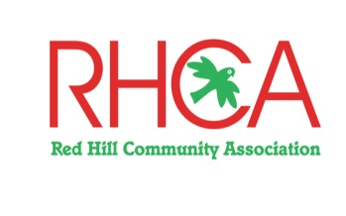

Community Park Opening
About 250 people came along to the official opening of the Red Hill Community Park at the end of January and stayed on after the speeches to enjoy the free BBQ organised by RHCA.
Rob Austin welcomed the crowd on behalf of the Bunurong Land Council and was followed by Greg Hunt MP, Martin Dixon MP, RHCA President David Maddocks and Mayor Graham Pittock who was helped to cut the ribbon by Red Hill Ward Councillor Tim Wood.
The excited shouts from the children using the new playground equipment were a delight to hear and daily use of the equipment since then ensures that the park is a valuable community asset now and into the future. Our thanks to everyone who volunteered on the day, we couldn’t have done it without you!
Sizzling Success
In an effort to raise funds to go towards finishing the war memorial, RHCA held a sausage sizzle at the Bunnings Rosebud store last month. We raised over $600 after expenses and are now looking to repeat the exercise later this year if possible.
If you would like to contribute to our memorial fund-raising, please contact us – we’d love to hear from you, as we need more money to finish the job.
Welcome, Carolynn!
RHCA bids a warm welcome to Carolynn Massola who has joined the Committee as Secretary & Public Officer. She replaces Kerry Watson who resigned last year and who we thank most sincerely for all the new ideas, hard work and effort she put into the job.

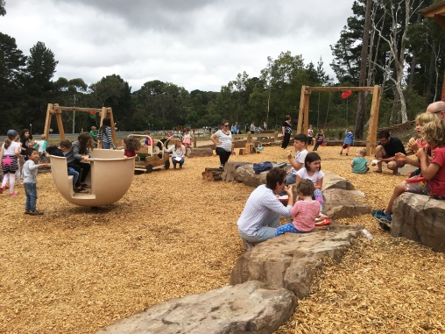

Roadside Litter
Did you see the article on littering in the current issue of Hill ‘n’ Ridge? We have noticed an increase in the amount of roadside litter in our area. The photograph below indicates just how much rubbish one person can collect in a short walk along a road, trail or parking area.

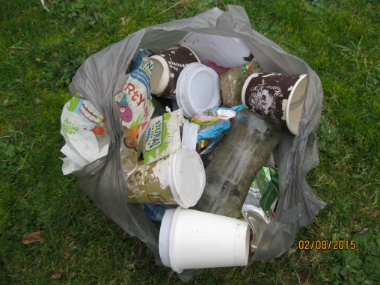
The littering thought process is incomprehensible and indicates a lack of respect for our surroundings. Some litter seems to attract more litter for some weird reason. If we all do a bit of picking-up it will be a great help. Unfortunately we do not see the Shire’s “Clean Team” often enough – maybe you could also call the Shire on 1300 850 600.
Open To All
RHCA is keen to involve the community in its activities. We want to demonstrate that we are working for the benefit of everyone and so we thought it would be a good idea to open our committee meetings to the general public. Come along and have a say as to what we can do on your behalf!
Our next meeting is on Thursday, 17 March at 5 pm, at the St. George’s Community Centre on Arthurs Seat Road.
We look forward to seeing you there!
Subscription Reminder
Membership of RHCA is per calendar year, and renewals were due in January.
If you need to renew your subscription or decide to join up please check our website for details or send email us.
NBN is Coming to You
Representatives from NBN Co. and Ericcson Australia will be here to answer all your queries on the NBN – due to be installed in Red Hill this year - and to let you know what we can expect of the “fast and efficient broadband services” in our area.
Come along to the Community Information Session in the Red Hill Hall in Mechanics Road on Friday, 4 March between 4.30 and 7.30 pm.

