We’re online at www.redhillcommunityassociation.com

Mobile Black Spots Targetted  June 2016 | 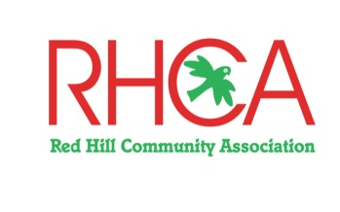

Two new Mobile Base Stations
Hon. Greg Hunt MP announced two new mobile phone base stations will be built in Shoreham and Red Hill to improve coverage in areas that have been ignored by service providers for commercial reasons. Funding comes from the Mobile Black Spot Program. The exact location of these base stations is yet to be finalised.

Indian Mynas
These birds are regarded as one of the most invasive animals on our planet.
You will no doubt have noticed their increasing numbers in your area, throughout the Mornington Peninsula and in all suburban areas.
They are a threat to our native birds as they destroy the eggs in the nest, they are aggressive, they take over nesting sites and have social traits that add to their invasive nature.
A new Mornington Peninsula Indian Myna Action Group has been formed.
Contact landcare facilitator Jaqui Salter by email to learn more about Indian Mynas and trapping them at Jacqui.Salter@mornpen.vic.gov.au or contact us.

Planting Out
The weather gods smiled down on the community park on 18 June and enabled a dedicated group of volunteers from local landcare groups and our own members to plant out 1200 tubestock around the playground area of the Community Park. Mostly grasses and sedges, they will transform the bare earth – indigenous plants only, of course.

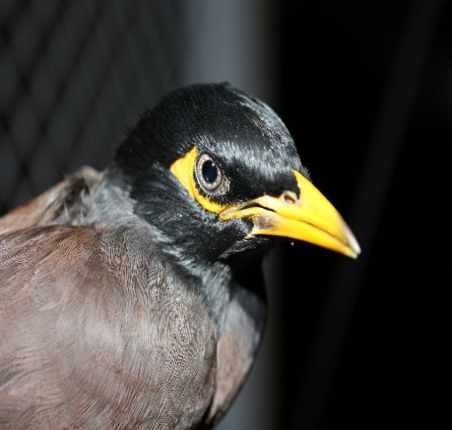
The Indian Myna4

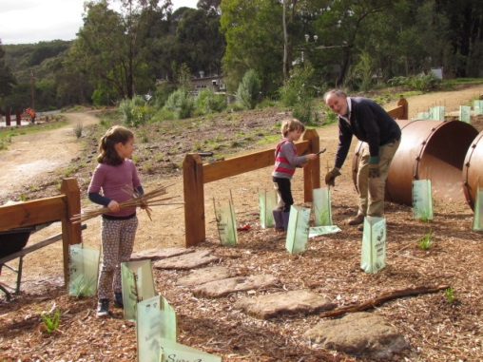
Planting fun in the Park

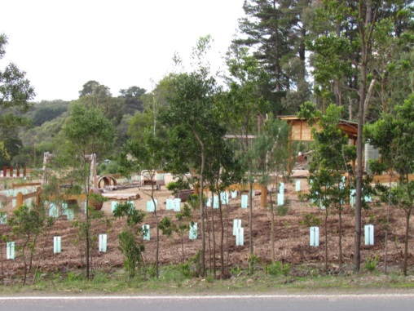
Now we’ll watch them grow
MTB Track
Those of you walking behind Blue Moon and the Epicurean won’t have failed to notice works underway for a mountain bike track near the old station area. This track will provide beneficial activity and entertainment for cyclists. We congratulate the Shire for pressing on with works in the Station Reserve Master Plan – but it’s a shame they didn’t remove the pines in the area first. Seems the Shire had to spend the $65,000 before June 30!

Op Shop’s Donation
Red Hill Op Shop has very kindly donated a BBQ shelter for the Community Park and it is expected to be installed next month.
At last, the BBQ has finally been connected and is working! We look forward to the wonderful aromas of sizzling onions and snags.

Character Study, Anyone?
Remember the “Character Study” that we have been urging the Shire to undertake for years? Well, it’s morphed into the Peninsula Design Framework and the first case study will be Red Hill! The project begins in October and the draft plan will be available to see in March 2017.

Come Along!
We are halfway through the six month trial period of inviting members of the public to come along to our committee meetings Please come along to see how RHCA works on your behalf.
Our next meeting is on Thursday, 21 July at 5 pm, at the St. George’s Community Centre on Arthurs Seat Road.

