APPLICATION FOR  MEMBERSHIP | 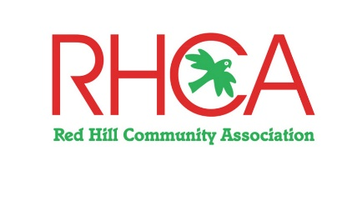

NAME(S) …………………………………………………………….………………………………….……
RESIDENTIAL ADDRESS ……...…………………….……………….……………………..…………...
MAILING ADDRESS (if different) ..……….……………………….……………………….…….………..
PHONE NUMBER …………………………….……….. MOBILE ………….……….………..……….
EMAIL ADDRESS ……………………………………….……………………………….….……………...
The membership fee is $30 per family for the Year 1 July 2020 – 30 June 2021. Please make cheques payable to Red Hill Community Association Inc. and send to the address below with the completed application form.

Preferably, you can make a payment directly into our bank account as follows – Account Name: Red Hill Community Association Inc. BSB No. 633-000. Account No. 1555 34290. At the Bendigo Bank. Please be sure to include your name/s, so we know who you are!

I enclose $__________ in payment for __________ Membership/s.

